Instructions for using the app for isotope plots for organic residue analysis (IPFORA)

This app was designed to produce two types of plots. The ellipse plots (called small delta plot) uses the major fatty acid components of modern reference fats (C_{16:0} and C_{18:0}) to calculate P=0.684 confidence ellipses for reference fats. The plot also includes an optional mixing model line to estimate where mixed fats would appear on the plot using the equation from Woodbury (1995) (See References below). The second plot (called big delta plot) uses the Δ¹³C value (calculated by using the difference in the δ¹³C values of the C_{16:0} and C_{18:0}) from modern reference fats to create 1 SD estimates of major fat groups (ruminant diary, ruminant adipose, etc). The app will use any modern reference fats that are supplied to the csv file and automatically calculate the ellipses and SDs needed.

To begin, these R packages need to be installed into your R session (this needs to only happen once after they are installed this step does not need repeating). Copy and paste these install codes into your R console and press enter.

install.packages (shiny)
install.packages (shinyjs)
install.packages (ggplot2)
install.packages (dplyr)
install.packages (shinydashboard)
install.packages (svglite)

Once these are installed you can open the R markdown sheet labelled ‘Isotope Plotting App’ in your R studio. To run this app press the green arrow (see Figure 1 with the arrow depicted in a red box.

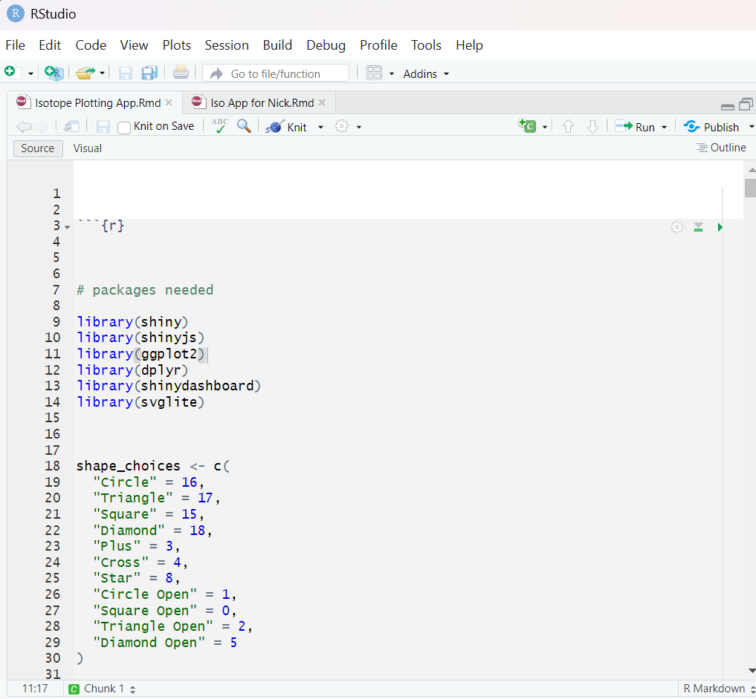
Figure 1: Green play button inside red arrow

This will open in your internet browser an app that looks like Figure 2 (see below).

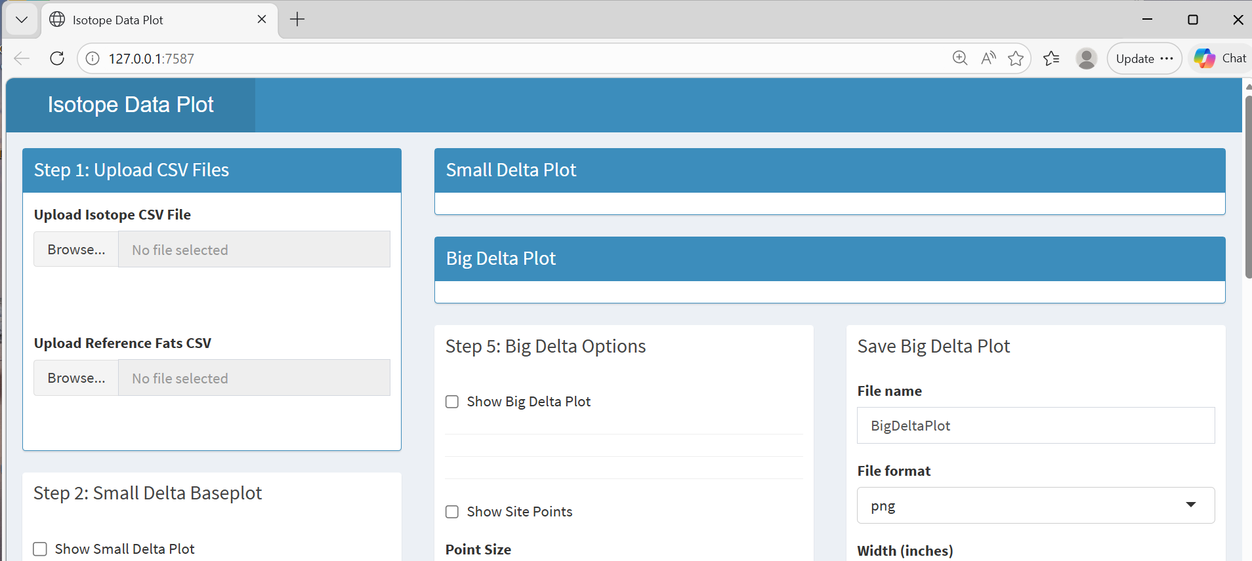
Figure 2: The app when first opened

To use this app you will need two csv files; one of your isotope values and one of your reference fats. The isotope value sheet must contain the following columns:
Site Period d13C16 d13C18 BIGDELTA
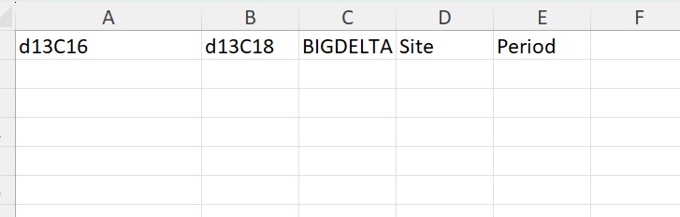
It can contain more than these columns (which will not affect anything in the app) but cannot contain any less or have differences in capitalization or spacing. The order of these columns also does not matter.

The Reference Fats csv must contain the following columns:
fatType d13C16 d13C18 D13C

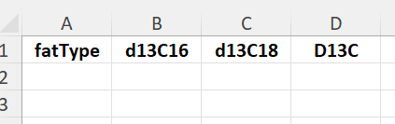

If you want to create mixing lines between ellipses, then it must also contain a column labelled C16Percent and C18Percent.
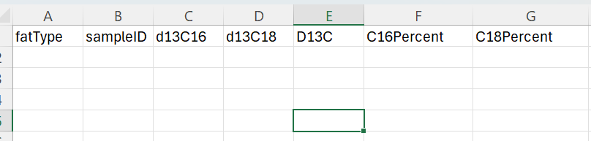

It can contain more than these columns (which will not affect anything in the app) but cannot contain any less or have differences in capitalization or spacing. The order of these columns also does not matter.

The numbers in the csv must be numerical, and any signs (such as minus signs) must use the mathematical signs (-) and not language signs (such as using an em dash instead of a minus sign). If numbers are on the left in an excel column, they are not numeric but text and need to be changed to numeric values.

Step 1: Upload CSV Files
Insert both of these csv files by pressing the ‘browse’ buttons in the Step 1: Upload CSV Files box. Make sure you upload the isotope csv to the upload Isotope CSV file selection (see Figure 3 red rectangle) and the reference fats csv to the Upload Reference Fats CSV selection (see Figure 3 black rectangle).


Figure 3: The isotope csv upload button in a red square and the reference fats button in a black square

The next steps are split between the Small Delta plot (steps 2 through 4) and the Big Delta plot (step 5 and 6). The Small Delta plot can be made without the Big Delta plot and vice versa.

Small Delta plot

Step 2: Small Delta Base plot

Step 2 creates the small delta base plot; the ellipses built off of the reference fats fatType column. First, check the ‘Show Small Delta Base plot’ checkbox (Figure 4 rectangle in green). Once checked, a base plot with ellipses will appear on the right in the Small Delta Plot box. Ellipses will only appear if there are 3 or more datapoints in the reference sheet with no overlap. The next three check boxes allows customization of these ellipses. The ‘Show Mixing Lines’ (Figure 4 rectangle in black) when checked will create a list of fat mixes based on the C16 and C18 percentages following the model from Woodbury (1995). If no line appears, there is no C16 and C18 percentages to draw from. The ‘Show Fat Legend’ (Figure 4 rectangle in yellow) when checked will automatically create a legend in the top left corner with names pulled from the fatType column. The ‘Custom Fat Ellipse Styling’ checkbox (Figure 4 rectangle in red) when checked will open options to change the colors and line types of the ellipses which will automatically update the plot as well as the legend. You can choose from the dropdown menu, or you can manually type in colors and linetypes. Ellipses can be turned off and on in the individual show ellipse check box (Figure 4 rectangle in red). The final checkbox, ‘Manually Adjust Axis’ (Figure 4 rectangle in purple) will allow you to manually type in the axis range you want which will adjust the plot automatically.

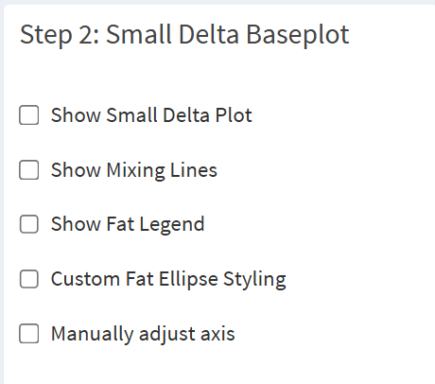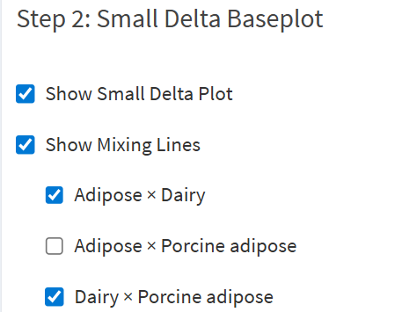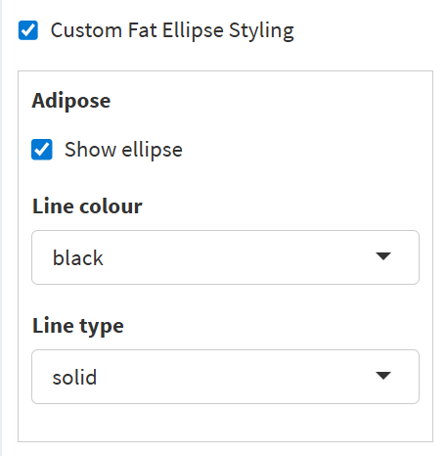

Figure 4: Small Delta Base plot options (left), mixing line options based off of C16 and C18 percentages drawn from a fat reference sheet from Dudd 1999 (middle), and the ellipse aesthetic options (right).

The final result will be a base plot matching the aesthetics you chose (See Figure 5). It is important to note; you must have the checkboxes you want checked on for the options to appear.
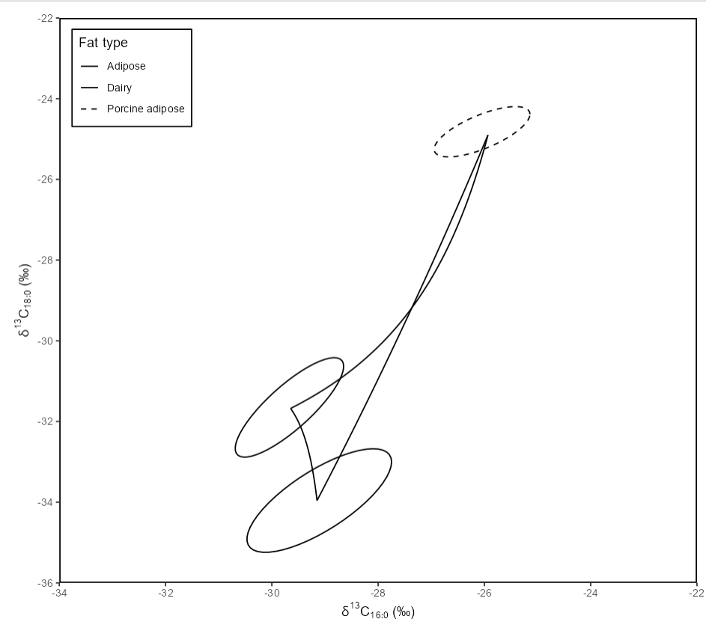
Figure 5: A baseplot with adjusted legend and ellipses and mixing lines from reference fats from Dudd (1999).

Step 3: Small Delta Options

The next step allows you to add your isotope data. This can be done with either site or period or both. If you only want site, check the ‘Show Site Points’ checkbox (Figure 6 red rectangle). You will also need to check the ‘site only’ button in Aesthetic Mapping (Figure 7) in order to adjust both color and points on the Sites. The purpose of Aesthetic Mapping is to be able to adjust color and shape for both site and period without overlapping more points. If both ‘Show Site Points’ and ‘Show Period Points’ are checked on, then you can choose in aesthetic mapping to have the color coordinate to site while shape is for period, or vice versa. If you only want site, then push ‘site only’ in Aesthetic Mapping and only have the Show Site Points checkbox clicked. If you only want Period, then only check the Show Period Points checkbox and the period only in Aesthetic mapping. When the Show Site Points is checked, a box will appear allowing you to choose how many sites (Figure 6 black rectangle). After making this choice, further boxes will appear labelled Select Site with dropdown menus (Figure 6 purple rectangle). The first drop down menu is correlated to the Site column on your csv and will allow you to choose a site. The next drop-down menu will let you change the color either by manually typing or by scrolling the dropdown. The final dropdown will let you change the shape the same way you chose color. The Point Size sliding bar lets you change the size of the points (Figure 6 yellow rectangle). These are the same options if ‘Show Period Points’ is checked (Figure 6 green rectangle). The important thing to remember is to click which button you want in Aesthetic Mapping (Figure 7) as this will change how these options operate.

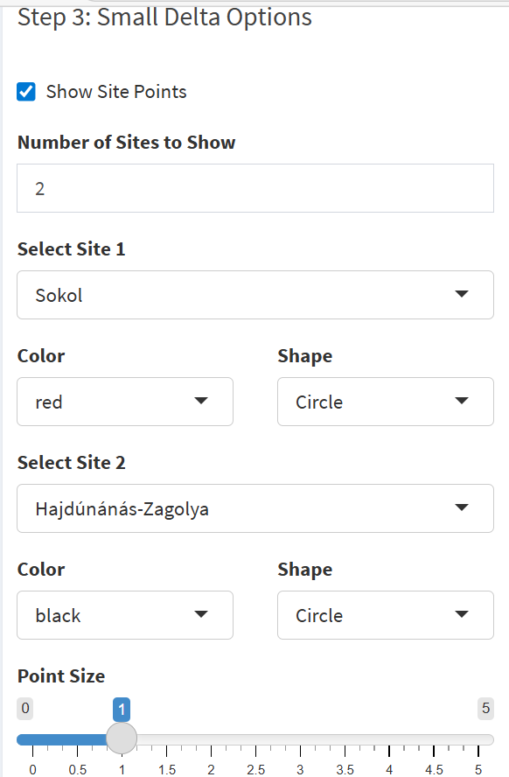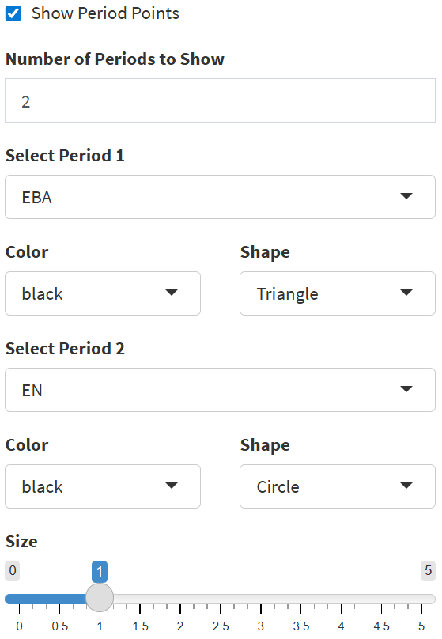
Figure 6: Step 3 Small Delta Options

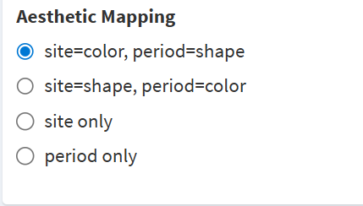
Figure 7: The Aesthetic Mapping options. When activated, site=color, period=shape will only change the color on the points using the site color and the shape will change based on the period shape. The option of site=shape, period=color means that the shape options come from the site options and the color options come from the period options. The site only allows the site options to change both color and shape. The period only allows the period options to change both color and shape.

The final option is the ‘Show Plot Title’ checkbox. When checked, a box appears that you can type in what title you want for the plot. As with any of the checkboxes, if you do not want this to be on, do not check it. You can uncheck it at anytime.

The end result of this will be a plot that looks something like Figure 8, depending on reference fats and isotope data.
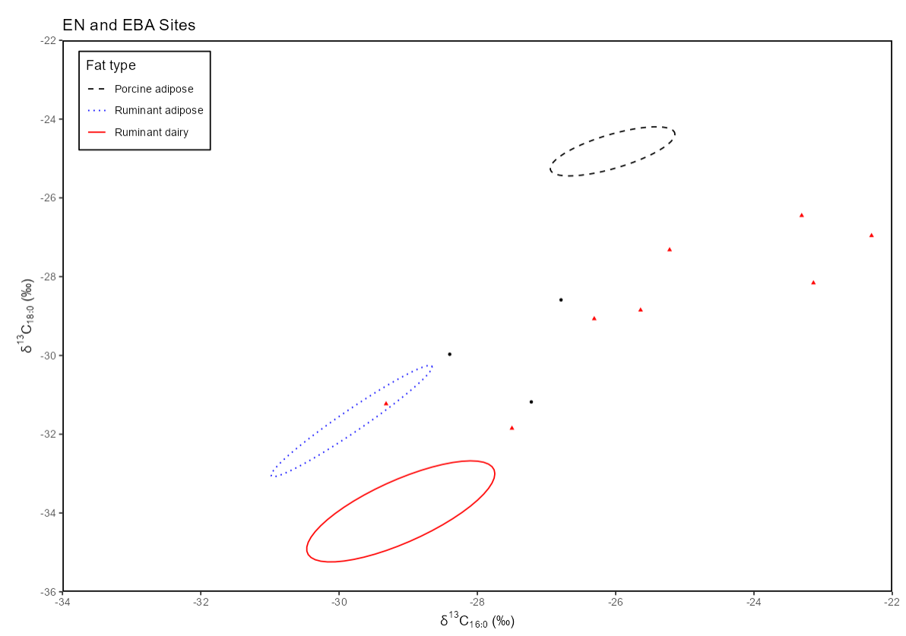
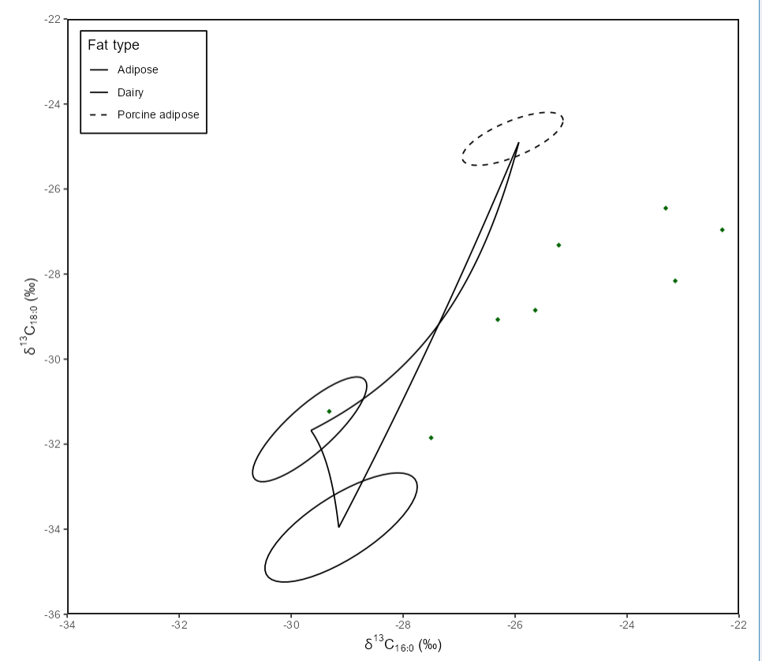
Figure 8: A small delta plot (left) showing sites in color (two sites one black and one red) and time period (eneolithic (circle) vs early bronze age (triangle) in shape. The reference fats are Dudd 1999, using only the ruminant dairy, ruminant adipose, and non-ruminant samples. The ellipses are drawn at .684 probability. The small delta plot (right) uses Dudd 1999 reference fats and one site only with no period, but includes mixing lines and different ellipse aesthetics.

Step 4: Save Small Delta Plot

The final step for the small delta plot is to save it. Manually type in your file name and then choose a file format (png, jpeg, svg), and a width and height in inches (See Figure 9). Then click the Save Plot button to save it directly to your computer.
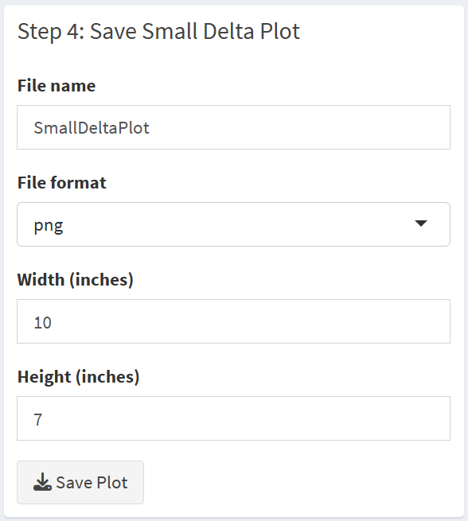
Figure 9: Step 4: Save Small Delta Plot options

Big Delta Plot

Step 5: Big Delta Options

This step will build your big delta base plot and insert your isotope data on it. First check the ‘Show Big Delta Plot’ checkbox (Figure 10 in the red rectangle). A blank Big Delta Plot will appear above this. You then have five options of fat types (Ruminant adipose, Ruminant dairy, non-ruminant adipose, non-ruminant dairy, aquatic) which will create means and 1 standard deviation error bars for these fat options (See Figure 11). You do not have to use them all. Click in the black box and choose from the drop down menu which fats you want to use for which of the five options (Figure 10 green rectangle). You can choose as many fats as you like; these fats come from the fatType column in your csv. So for example, if you have ‘cow adipose’ and ‘sheep adipose’ and you want both of them to be in the ‘ruminant adipose’ section, click both these options. If you do NOT want one of these five options, for example you do not want non-ruminant dairy, then just leave it blank. Shaded grey rectangles will appear in the mixing zones (see Figure 11). It is important to note that as non-ruminant dairy tends to overlap ruminant adipose and non-ruminant adipose, the grey shaded bar for non-ruminant dairy extends from the min and max of the error bars.

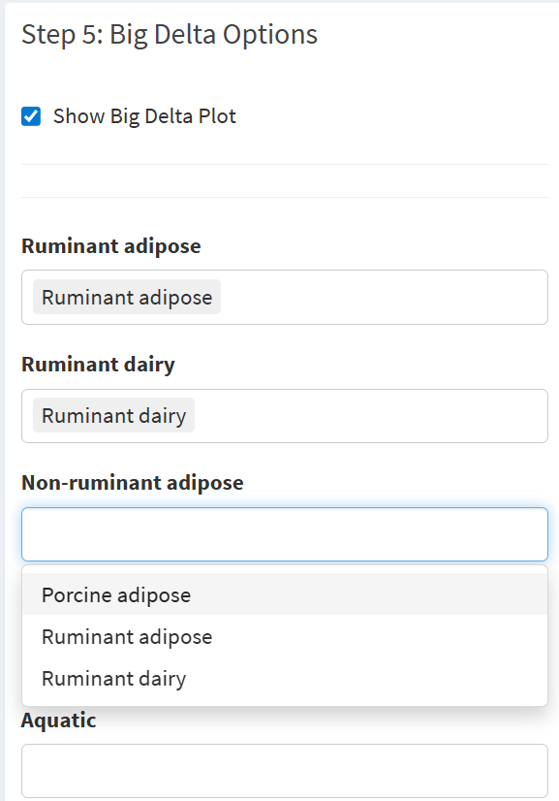
Figure 10: The options for the base plot for the big delta plot. The dropdown menu for non-ruminant adipose has been activated to choose which fat options should be included in this section. Ruminant adipose and Ruminant dairy have already been chosen for those sections. Aquatic has been left blank.

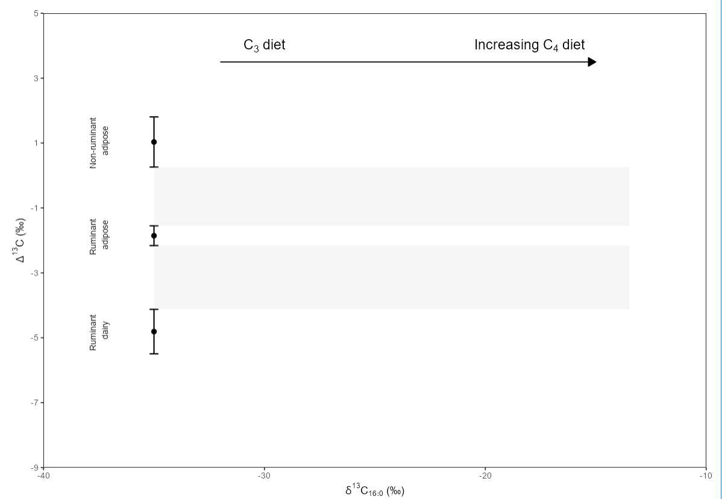
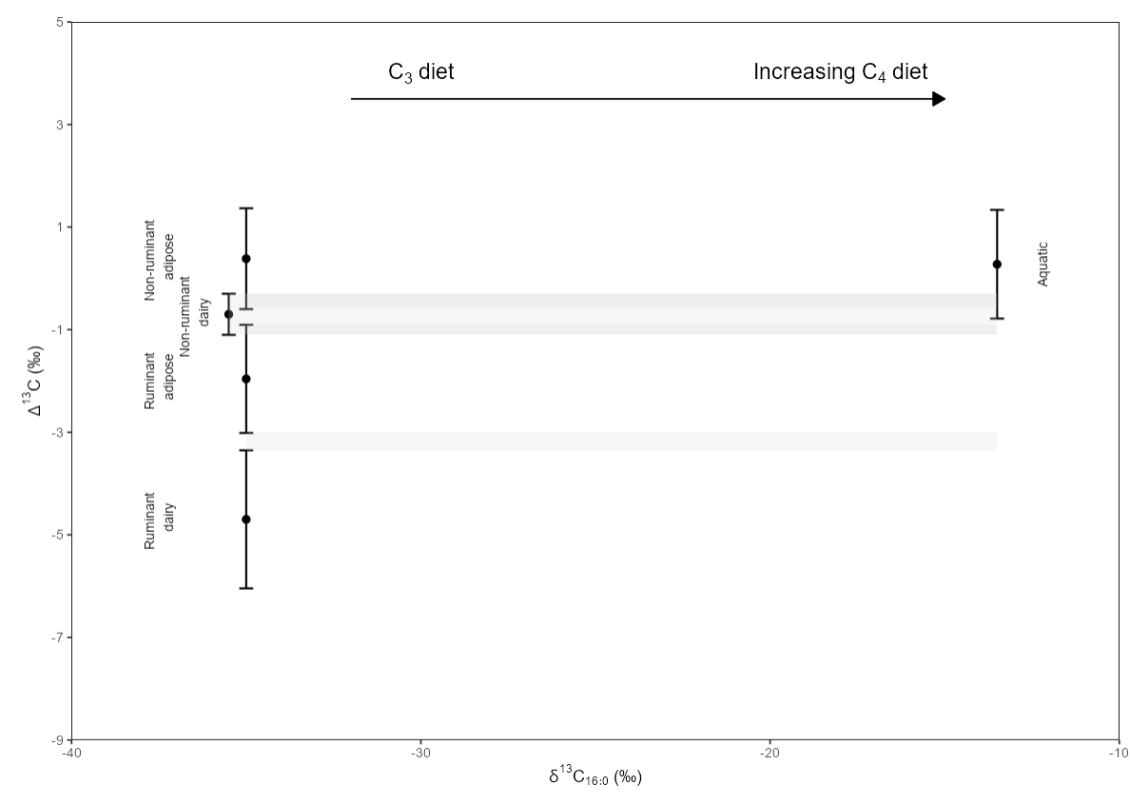
Figure 11: A base plot for a big delta using Dudd 1999 (top) and a baseline using Outram 2009 and Dudd 1999 (bottom).

Adding your isotope values works the same as the small delta options (see above) with the show site options, show period options, Aesthetic Mapping, and show plot title options. Again, it is important to decide your Aesthetic Mapping and activate it.

Step 6: Save Big Delta Plot
The final step for the big delta plot is to save it. Manually type in your file name and then choose a file format (png, jpeg, svg), and a width and height in inches. Then click the Save Plot button to save it directly to your computer.

References:

The mixing model for fats is based on Woodbury (1995) cited as:

Woodbury, S.E., Evershed, R.P., Rossell, J.B. Griffith, R.E. and Famell, P. (1995) Detection of vegetable oil adulteration using gas chromatographic combustion/isotope mass spectrometry. Anal. Chem. 67, 2685-2690

The mixing model equation is below as found in Dudd 1999:
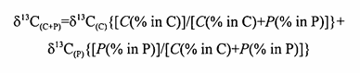

C represents Fat 1 and P represents Fat 2. δ¹³C_{(C+P)} is the predicted isotope ratio with contributions from both Fat 1 and Fat 2. δ¹³C_{(C)} is the isotope ratio of the fatty acid in Fat 1. δ¹³C_{(p)} is the isotope ratio in Fat 2. C is the concentration of Fat 1 present (%) and P is the concentration of Fat 2 present (%). % in C is the amount of the fatty acid in Fat 1 and % in P is the amount of fatty acid in Fat 2 (Dudd 1999).

The mixing curves and lines that are created from this equation works on calculating the predicted isotope ratio using the proportions of Fat 1 mixed with Fat 2 in 10% increments starting with 100% and ending with 0%. A full explanation can be found in Dudd 1999 Appendix 7 (pages 395 to 396).

Molecular and isotopic characterisation of animal fats in archaeological pottery.
Dudd, S. N. PhD Thesis. 1999

